ASSESMENT – 3

SQL

S

● Write SQL query to solve the problem given below

1. query

● Write sql query to find the items whose prices are higher than or equal 250rs. Order the result by product price in descending, then product name in ascending. Return pro_name and pro_price

ANS = SELECT pro_name, pro_price

FROM item_mast

WHERE pro_price >= 250

ORDER BY pro_price DESC, pro_name ASC;

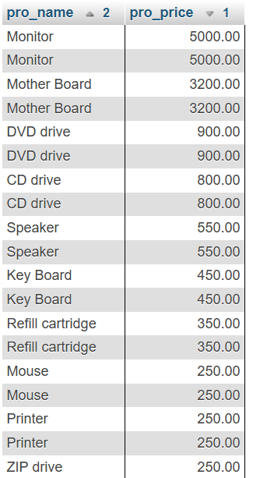

2. query

● Write a sql query to find the cheapest item. Return pro_name and pro_price.

ANS = SELECT pro_name, pro_price

FROM item_mast

ORDER BY pro_price ASC

LIMIT 1;

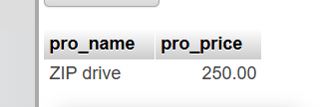

3. query

Write the sql query to calculate the average price of the items for each company. Return average price and company code.

ANS = SELECT pro_com, AVG(pro_price) AS average_price

FROM item_mast

GROUP BY pro_com;

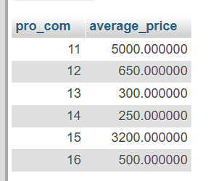

4. query

● Write the sql query to find the average total for all the product mention in the table

ANS = SELECT AVG(pro_price) AS average_price

FROM item_mast;

